**Netflix Stock Price EDA 2023-2024**

**Problem Definition:**

Conduct an Exploratory Data Analysis (EDA) on Netflix stock price data for the years 2023–2024. In this analytical research, we look into the complex environment of Netflix's stock values, using a comprehensive dataset spanning 2023–2024.

**Objectives:**

1. **Understand Stock Price Trends:**

* Analyse the historical trends in Netflix stock prices over the specified period.
* Identify any patterns, cycles, or trends in the stock price movements.

1. **Assess Volatility and Risk:**

* Evaluate the volatility of Netflix stock by examining the variance or standard deviation of daily or weekly returns.
* Assess the risk associated with investing in Netflix stock during the period under consideration.

1. **Correlate with Market Events:**

* Investigate how Netflix stock prices correlate with significant market events, such as earnings releases, product launches, or industry news.
* Determine if there are any notable price movements associated with specific events.

1. **Compare Performance:**

* Compare Netflix stock performance with relevant benchmarks, such as stock market indices or competitors in the streaming industry.
* Assess whether Netflix stock outperformed or underperformed relative to these benchmarks.

1. **Identify Seasonality:**

* Explore if there is any seasonality or recurring patterns in Netflix stock prices.
* Determine if certain months or quarters exhibit consistent trends in stock performance.

1. **Provide Insights for Investors:**

* Summarize key findings and insights derived from the analysis to help investors make informed decisions regarding Netflix stock.

1. **Visualization:**

* Create informative visualizations, such as line plots, candlestick charts, or heatmaps, to illustrate the findings effectively.

**Methodology:**

The methodology adopted for this project includes: a) understanding the objective of work, b) collection of the data from kaggle, c) data pre-processing and data wrangling, d) data processing and data mining, e) plotting visualizations of data series, and f) data visualizing and analyzing the results.

## Implementation:

The implementation done for this project includes:

* Importing data
* Importing libraries
* Data preprocessing and feature analysis
* Plotting visualisation
* Netflix stock price trend
* Netflix stock candlestick chart
* Netflix stock volatile periods
* Fluctuations in Netflix stock prices
* Percentage growth comparisons- Netflix vs S & P index(^GSPC)
* Netflix stock volumes
* Calculating stock return
* Line plot
* Plot histogram
* Plot kernel density estimation
* Correlation heatmap
* Differencing method
* Seasonal plot of closing prices over months.

**Data Collection and Data Preprocessing:**

**Data Collection:** The dataset is sourced from Kaggle, a recognized data science platform. The dataset is "NFLX.csv", which provides Netflix insightful data on stock values over time.

**Dataset Overview:** This dataset contains data related to Netflix (NFLX) stock prices with various columns. Here's a brief explanation of each column:

* Date: This column represents the date of the stock market trading day.
* Open: The opening price of Netflix stock on a particular trading day. It is the price at which the first trade occurs for the day.
* High: The highest price at which Netflix stock traded during the day.
* Low: The lowest price at which Netflix stock traded during the day.
* Close: The closing price of Netflix stock on a particular trading day. It is the last price at which a trade occurred for the day.
* Adj. Close: The adjusted closing price takes into account events like dividends, stock splits, etc., and provides a more accurate reflection of the stock's value.
* Volume: The total number of shares traded on that particular trading day.

**Data Understanding:**

To understand the dataset, examine the distribution, summary statistics, and unique values of each column. Initial analysis identifies possible areas for feature engineering and preprocessing.   
This insight informs subsequent processes in data preparation in order to compare the stock prices.

**Data Preprocessing:**

The following actions are conducted during the data preparation phase, which is essential for guaranteeing the quality and applicability of the dataset for tasks that follow:

1. Cleaning Data:

- Removal of rows with null values, ensuring data completeness.

- Removal of duplicate records to enhance dataset integrity.

2. Convert data types:

- Adjusting the data types of specific columns in the dataset

2. Handling Outliers:

- Replacement of outliers with the median value, maintaining data consistency and accuracy.

- Perform any required normalization or scaling

3. Dealing with Null Values:

- Identification and assessment of null values in the dataset.

- Imputation of missing values using appropriate strategies or removal of affected records.

All of these procedures work together to guarantee that the dataset is cleaned, that outliers are dealt with, and that missing values are handled properly. Following preprocessing, the data is prepared for exploratory data analysis.

**Exploratory Data Analysis (EDA):**

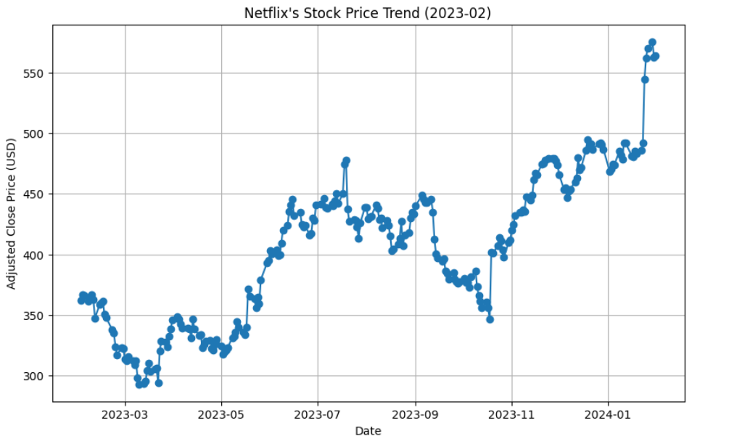Exploratory Data Analysis (EDA) for Netflix stock prices from 2023-2024 involves examining and visualizing the data to understand its characteristics, trends, and potential relationships. This gives a basic idea of price distribution and volatility. Here's a breakdown of the process:

* The graph represents Netflix’s stock price movement over a year, from March 2023 to February 2024. The y-axis shows the adjusted close price in USD, while the x-axis represents the date.
* The stock price exhibits fluctuations, with noticeable dips and peaks. These variations indicate market volatility and investor sentiment.
* Towards the end of the period, there is a significant upward trend, suggesting positive growth or impactful business developments for Netflix.

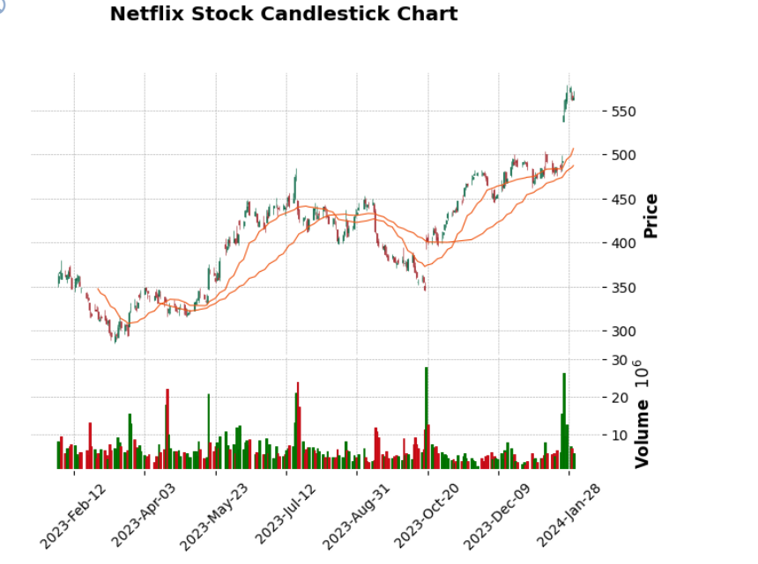

* The graph represents Netflix’s stock price movement over a year, from March 2023 to February 2024. The y-axis shows the adjusted close price in USD, while the x-axis represents the date.
* The stock price exhibits fluctuations, with noticeable dips and peaks. These variations indicate market volatility and investor sentiment.
* Towards the end of the period, there is a significant upward trend, suggesting positive growth or impactful business developments for Netflix.

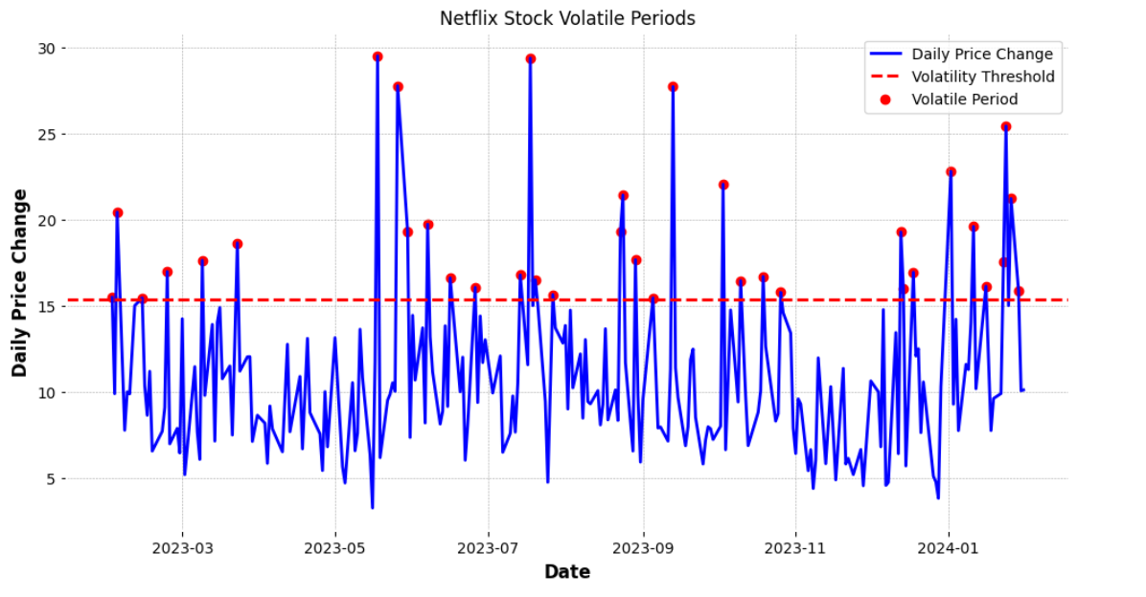

* The graph represents Netflix’s stock price movement over a year, from March 2023 to February 2024. The y-axis shows the adjusted close price in USD, while the x-axis represents the date.
* The stock price exhibits fluctuations, with noticeable dips and peaks. These variations indicate market volatility and investor sentiment.
* 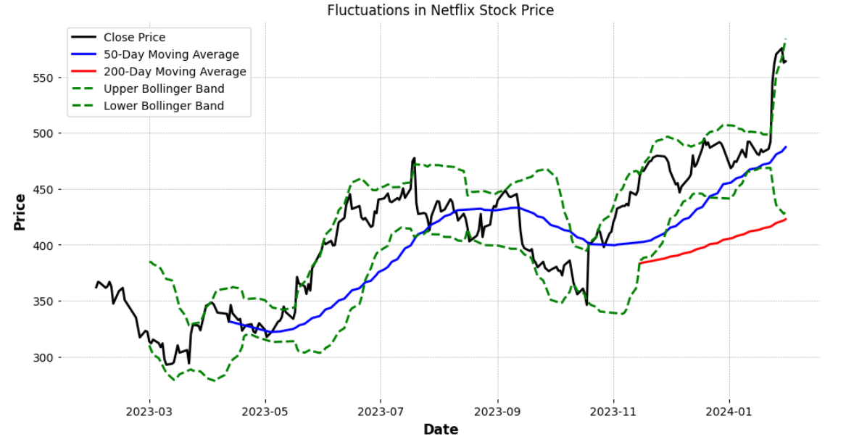Towards the end of the period, there is a significant upward trend, suggesting positive growth or impactful business developments for Netflix.
* The graph represents Netflix’s stock price movement over a year, from March 2023 to February 2024. The y-axis shows the adjusted close price in USD, while the x-axis represents the date.
* The stock price exhibits fluctuations, with noticeable dips and peaks. These variations indicate market volatility and investor sentiment.
* Towards the end of the period, there is a significant upward trend, suggesting positive growth or impactful business developments for Netflix.

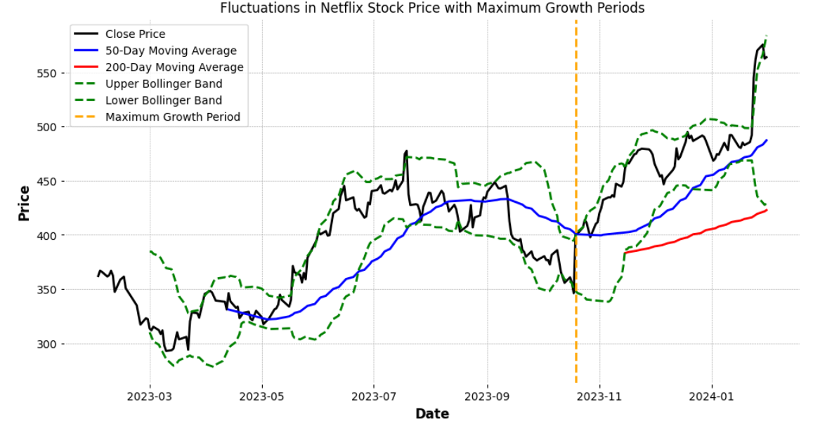

* The graph represents Netflix’s stock price movement over a year, from March 2023 to January 2024. The y-axis shows the adjusted close price in USD, while the x-axis represents the date.
* Technical Indicators: Different lines correspond to various technical indicators:

1. Close Price: The blue line indicates the daily closing price of Netflix stock.
2. 50-Day Moving Average: The orange line represents the average stock price over the past 50 days.
3. 200-Day Moving Average: The green line shows the average stock price over the past 200 days.
4. Upper and Lower Bollinger Bands: The upper and lower dashed lines denote the Bollinger Bands, which indicate potential price volatility.

* Maximum Growth Period: Notably, there is a significant upward trend labelled as the “Maximum Growth Period,” suggesting positive momentum for Netflix’s stock.

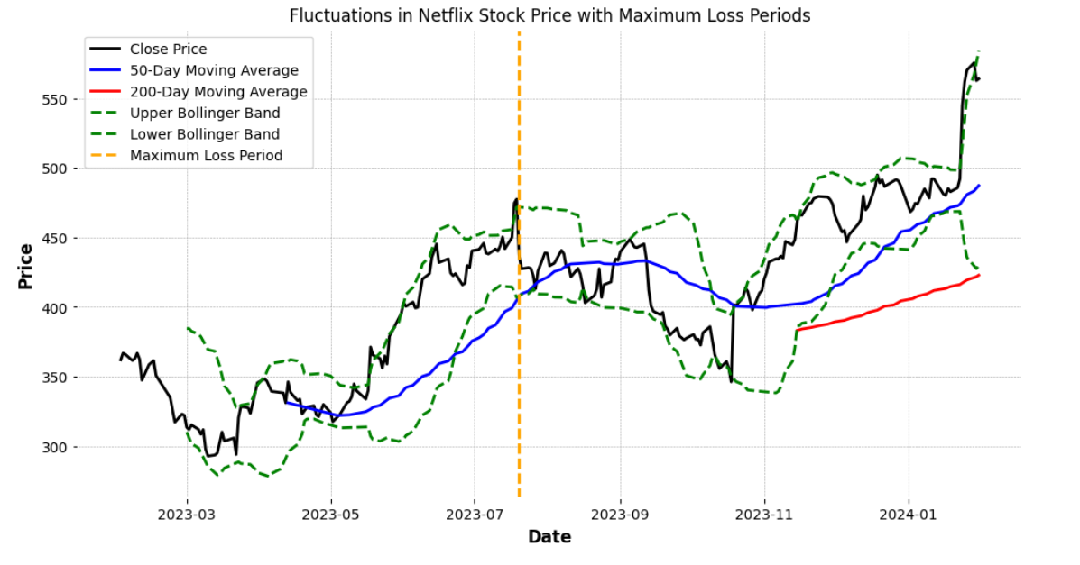

* The graph represents Netflix’s stock price movement over a year, from March 2023 to January 2024. The y-axis shows the adjusted close price in USD, while the x-axis represents the date.
* Notably, there is a significant downward trend labelled as the “Maximum Loss Period,” suggesting negative momentum for Netflix’s stock.

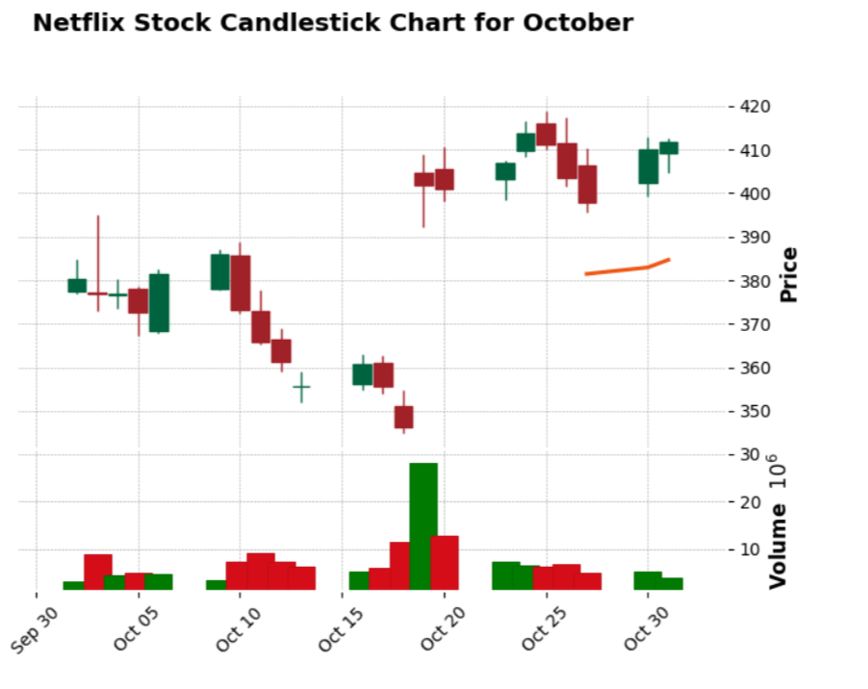

* + The graph represents the stock performance of Netflix during the month of October, uses candlestick patterns to visualize daily price movements.
  + Each candlestick shows the open, close, high, and low prices for a specific trading day.
* Streaming pioneer Netflix, opens new tab showed resilience by gaining more quarterly subscribers than in the past three years despite strikes by Hollywood's writers and actors, sending its shares up 16.23% on 19th october 2023.
* Reason: adding that paid-sharing has opened up a bigger-than-expected market of potential subscribers for Netflix. Notably, there’s a significant increase in trading volume around October 20. Higher volume often indicates increased market activity or investor interest.

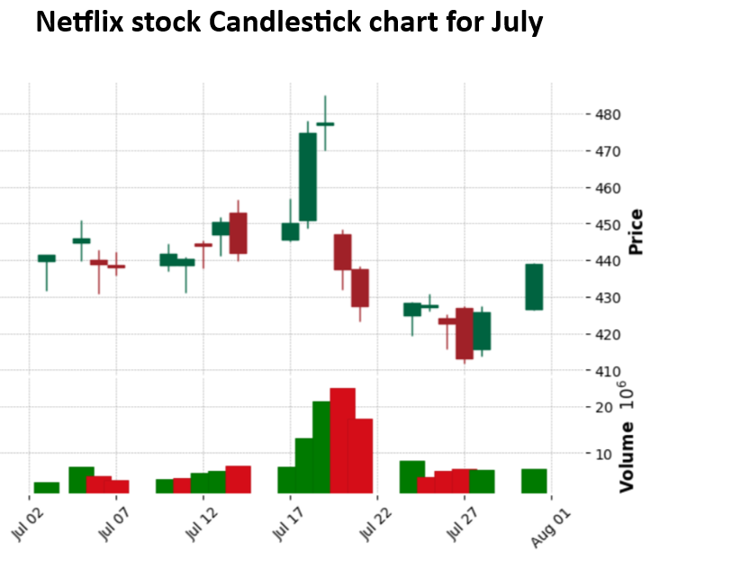

* + The graph represents the stock performance of Netflix during the month of July, uses candlestick patterns to visualize daily price movements.
* Shares of Netflix, opens new tab tumbled more than 8% on july 20 2023 after the video-streaming pioneer's lackluster revenue rise sparked concerns of a longer road to growth from its new initiatives.
* Reason: The company has been fighting off rivals Disney+ and Amazon's Prime Video in an industry that is showing signs of saturation in the United States. Many of the company's new sign-ups are in countries where it charges lower prices.

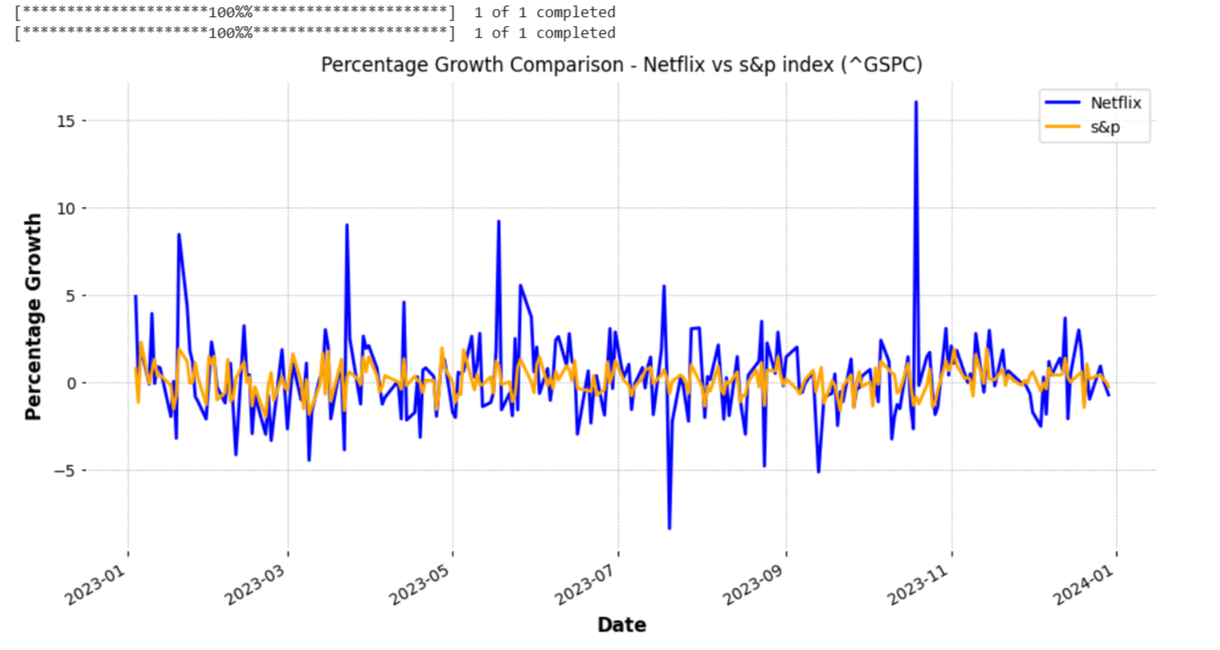

**Data Visualisation:**

Data visualization utilizing Google Colab and given code can provide valuable insights into stock prices. The following aspects are discussed:

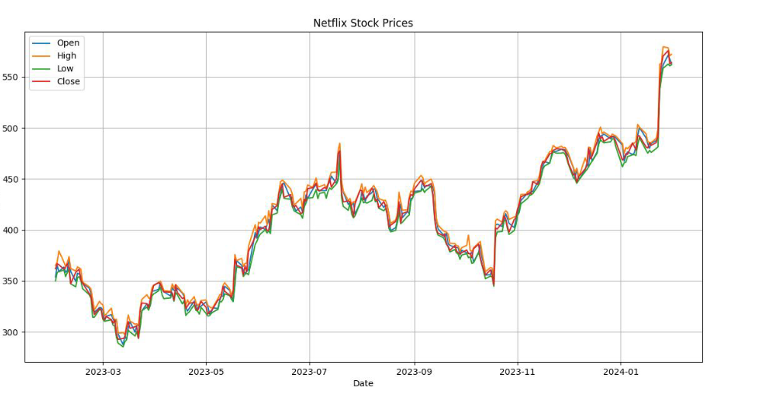

* This plot shows the daily opening, high, low, and closing prices of Netflix stock over

time.

* The x-axis represents the dates, and the y-axis represents the price of the stock. Different lines represent different price indicators: open (starting price), high (highest

price), low (lowest price), and close (ending price) for each day.

* This visualization helps to understand the trend and volatility of the stock prices over the selected time period.

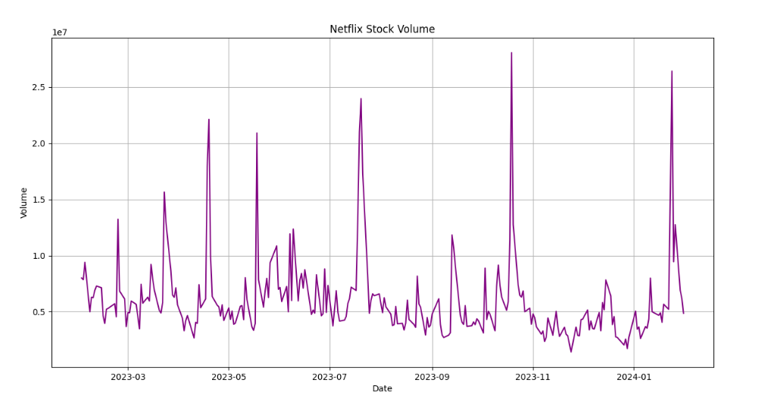

* This plot shows the daily trading volume of Netflix stock over time.
* The x-axis represents the dates, and the y-axis represents the volume of shares traded.
* The colour of the line represents the volume of trading activity on each day.
* This visualization helps to understand the level of investor interest and liquidity in the

stock over time.

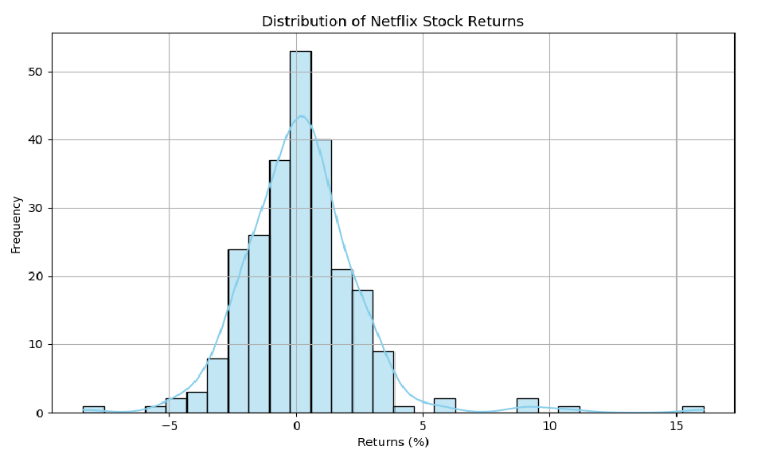

* This histogram shows the distribution of daily returns of Netflix stock.
* The x-axis represents the returns (%) and the y-axis represents the frequency of occurrences.
* The histogram provides insights into the volatility and distribution of returns, helping to assess the risk associated with the stock.

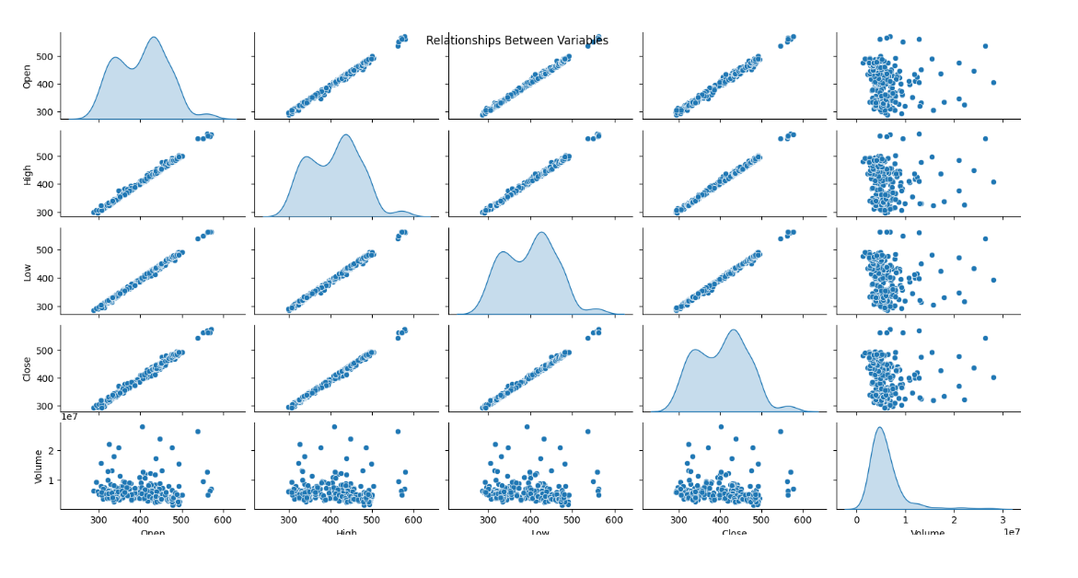

* This histogram shows the distribution of daily returns of Netflix stock.
* The x-axis represents the returns (%) and the y-axis represents the frequency of

occurrences.

* The histogram provides insights into the volatility and distribution of returns, helping

to assess the risk associated with the stock.

* This plot displays pairwise relationships between the opening, high, low, closing

prices, and volume of Netflix stock.

* The diagonal plots show the distribution of each variable, while the off-diagonal plots

show the relationships between variables.

* The density plots (kernel density estimation) along the diagonal provide information

about the distribution of each variable.

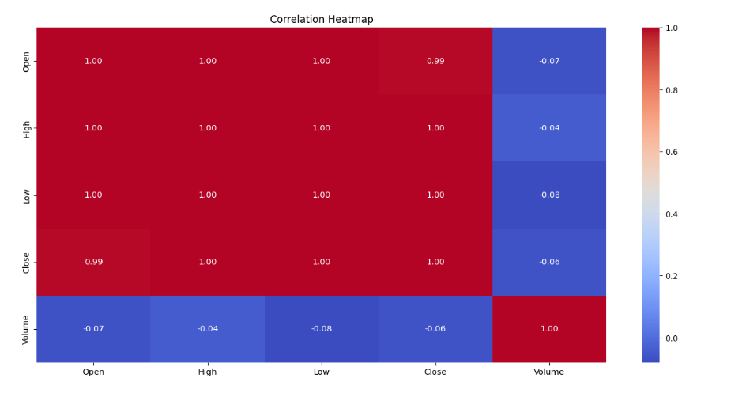

* This heatmap shows the correlation matrix between the opening, high, low, closing

prices, and volume of Netflix stock.

* The colour intensity and the corresponding values indicate the strength and direction

of the linear relationship between pairs of variables.

* This visualization helps to identify which variables are positively or negatively

correlated with each other.

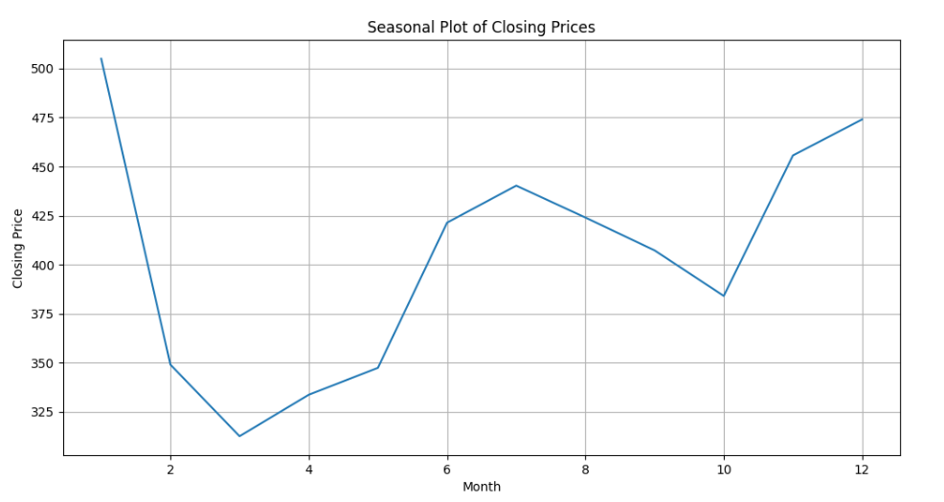

* This plot shows the seasonal pattern of Netflix stock closing prices over the months.
* The x-axis represents the months, and the y-axis represents the closing price of the

stock.

* This visualization helps to identify any recurring patterns or trends in the closing

prices of the stock over different months of the year.

**Conclusion:**

In the context of Netflix's stockprices, this study can help investors make well-informed decisions, identify risk factors, and manage their portfolios. The development of more complex predictive models and investment strategies could be achieved by conducting additional analysis and modeling.

## As a whole, investors should start with the EDA. With the help of more sophisticated financial analysis and modeling, it offers a fundamental comprehension of Netflix's stock behavior that can be used to guide future inquiry and decision-making.

## Team 15 - NETFLIX STOCK PRICE EDA 2023-2024

## Team Members:

## 21BCE9644-V. DIVYA

## 21BCE9963-S. DEVI PRIYANKA

## 21BCE9939-M. VANDANA

## 21BCE9891-R. HIMA ASWITHA

## 21BCE9092-SUSHANTH

## 21BCE7930-JOHN SAMUEL

## 21BCE8923-NAVTEJ

## 21BCE9339-CH. PRASANTH